IALA Guideline

Gnnnn
Guideline on Digitalization of Waterways

Edition x.x
Date (of approval by Council)

urn:mrn:iala:pub:gnnnn
Revisions to this document are to be noted in the table prior to the issue of a revised document.
Date | Details | Approval

1. Introduction 6
1.1. Overview 6
1.2. Scope 6
1.3. Intended audience 6
2. Digitalisation Maturity 7
2.1. Overview 7
2.2. Digital maturity frameworks and standards 7
2.3. Capability maturity model for waterways 7
2.4. Digitalisation challenges 10
2.4.1. Increased interdependency 10
2.4.2. Match-principle 10
2.4.3. Mixed traffic conditions 10
3. Digital model, shadow and Twin 13
3.1. Overview 13
3.2. Development of Digital models 14
3.2.1. Data management plan 14
3.2.2. Information presentation system 16
3.2.3. Sensor network 16
3.2.4. Connectivity 16
3.2.5. Usage 17
3.3. Practical deployment examples 17
3.3.1. Vessel traffic management 17
3.3.2. Remotely monitored floating visual Aids 18
3.3.3. AtoN on-demand 18
4. Digital Services for navigation 20
4.1. Overview 20
4.2. Development of digital maritime services 20
4.2.1. Operational requirements 20
4.2.2. Information exchange methods 22
4.2.3. Connectivity 25
4.3. Maturity of digital maritime services 26
4.4. Practical deployment examples 27
4.4.1. Route exchange service 27
4.4.2. Maritime Safety Information service 27
5. Architectures for Digitalisation of waterways 28
5.1. Overview 28
5.2. overarching e-navigation architecture 28
5.2.1. Shipboard navigation system architecture 29
5.2.2. Common shore-based system architecture 30
5.3. Maritime system interconnection architecture 31
5.4. Maritime architecture framework 32
6. DEFINITIONS 35
7. abbreviations 37
8. references 38
9. Further reading 39

List of Tables
Table 1 Baseline information for digital waterway models. 15
Table 2 Maritime Services in the Context of e-Navigation. 21
Table 3 Operational River Information Services (RIS) defined by PIANC. 22
Table 4 List of known IHO S-100 based product specifications. 23
Table 5 List of Application Specific Messages approved by IMO. 24
Table 6 Airport runway service categories. 26
Table 7 Digital maturity levels of navigational services. 26
Table 8 Different architecture frameworks. 28

List of Figures
Figure 1 Five levels of digitalisation maturity model for waterways domain. 8
Figure 2 Digitalisation maturity levels applied to the waterway domain. 9
Figure 3 Mixed traffic, waterway infrastructure (authorities), and operational centres (shipping companies). 11
Figure 4 Communication relationships between shore and ships of different levels of autonomy. 12
Figure 5 Digital Model - Digital Shadow – Digital Twin. 13
Figure 6 Digital twin in waterway management. 13
Figure 7 Example of AtoN remote monitoring information. 18
Figure 8 Example of an on-demand AtoN used for increasing the intensity of AtoN lights based on traffic information from AIS (yellow trigger areas) and prevailing visibility (blue visibility meter). 19
Figure 9 An Example of relationships between specifications of IMO Maritime Services, technical services, S-100 data models/product specifications, and connectivity. 23
Figure 10 S-124 based Maritime Safety Information service. 27
Figure 11 Overarching e-navigation architecture 29
Figure 12 Generic shipboard navigation system architecture in the context of e-navigation. 30
Figure 13 Structural overview on Common Shore-based System Architecture (CSSA). 31
Figure 14 Maritime System Interconnection Architecture. 32
Figure 15 Maritime Architecture Framework with layers along interoperability axis. 33

Introduction

Overview

This guideline intends to define and explain what is meant by the digitalisation of a waterway. It also explains how digitalisation can benefit the safety and efficiency of navigation, environmental protection, and the efficient maintenance of waterways and individual waterway infrastructure components. A waterway with digital capabilities can support the initiation of proactive corrective actions for individual vessels or for vessel traffic in general, taking prevailing conditions into account in real-time, and can support more optimised and predictive maintenance of waterway infrastructure, such as Aids to Navigation (AtoNs).
Section 2 of this guideline introduces the concept of digital maturity, the methods used to determine it, and how it can be applied to a waterway and its associated infrastructure, data, and services. In addition, this section addresses certain challenges that must be taken into account in the digitalisation of waterways, such as the need to support various mixed traffic scenarios.
Section 3 explains the concepts of digital model, digital shadow and digital twin, and how these can be applied.
Section 4 discusses digital services that can be provided to vessels.
Section 5 introduces architectures that support the methodical digitalisation of a waterway. Several architectures are presented, each taking a particular perspective, while all mutually support one another.

Scope

This Guideline considers the digitalisation of a waterway as a process of increasing the digital maturity of a waterway and its services. This process comprises three themes:
- Creating a digital model of waterways, which may be further developed into a digital shadow and ultimately into a digital twin.
- Providing digital services to vessels to support safe and efficient navigation within waterways and vessel traffic management.
- Governing the interactions of the above through a set of mutually supportive digitalisation architectures.
The Guideline provides guidance on issues to be considered when planning digitalisation, describes the measures needed to develop digital models and to prepare for the provision of digital services. It also presents selected practical deployment examples. Detailed technical implementation guidance is outside the scope of this Guideline.

Intended audience

This Guideline is intended to assist administrations responsible for the maintenance of waterways or the provision of navigational services to vessels in planning the digitalization of waterways. It outlines the actions to be considered and identifies relevant international standards to be applied.

Digitalisation Maturity

Overview

This section introduces the concept of digitalisation maturity and explains how it can be assessed and applied to waterways and its infrastructure, data, and services. Digitalisation maturity describes how effectively digital technologies support operations, decision making and collaboration between different entities. Digital maturity should not be confused with technology readiness levels (TRL).
Maturity can be assessed at different levels starting from organisational level down to the level of individual digital models and services. For waterways, it may be practical to assess separately the maturity of waterway digital models, and the digital navigational services provided for the users of the waterway.
If the digital model of a waterway is created primarily for maintenance purposes, it is up to the administration to define the target digitalisation maturity level independently. However, in case of defining target maturity level for digital navigational services, administrations need to consider also the end user capabilities and various mixed traffic conditions.
Higher maturity levels require harmonised interfaces, reliable connectivity and interoperability between systems.

Digital maturity frameworks and standards
There are existing guidance and standards available for assessing the digital maturity levels of organizations, systems, processes or digital models and these can also be applied to waterway infrastructures and services. Such frameworks support organisations in defining target maturity levels and identifying areas for improvement; however, access to some standards is restricted and subject to paywall.
Several widely used digital maturity models are available for evaluating the digital maturity of organisations (e.g. MIT Sloan, Deloitte, Gartner and TM Forum digital maturity models [1]). These models typically assess digital capabilities across multiple dimensions such as strategy, culture, technology, data, and processes. The maturity of each dimension is usually evaluated using a five-level scale. The results support organisations in identifying gaps and prioritising improvements required to achieve the desired level of digitalisation. In addition, some maturity models have been developed specifically to assess the digital maturity of ports [2][3].
ISO/IEC has published a number of standards (330xx series) to support the assessment of IT-related maturity levels. Furthermore, the joint ISO/IEC technical committee has recently published generic guidance for digital twin maturity assessments [4]. This guidance defines a generic digital twin maturity model, specifies assessment indicators, and provides guidance for conducting maturity assessments, thereby supporting interoperability and a structured assessment approach.

Capability maturity model for waterways
A project, addressing digitalisation in the European inland waterway system, called Masterplan Digitalisation of Inland Waterways (DIWA) developed a simplified maturity model for waterway domain [5] as shown in Figure 1. This maturity model is based on the much more elaborate Capability Maturity Model (CMM) [6] and has five levels: Reactive, Organised, Digitised, Connected and Intelligent. Although originally developed for inland waterways, the model can easily be adapted to marine domain.
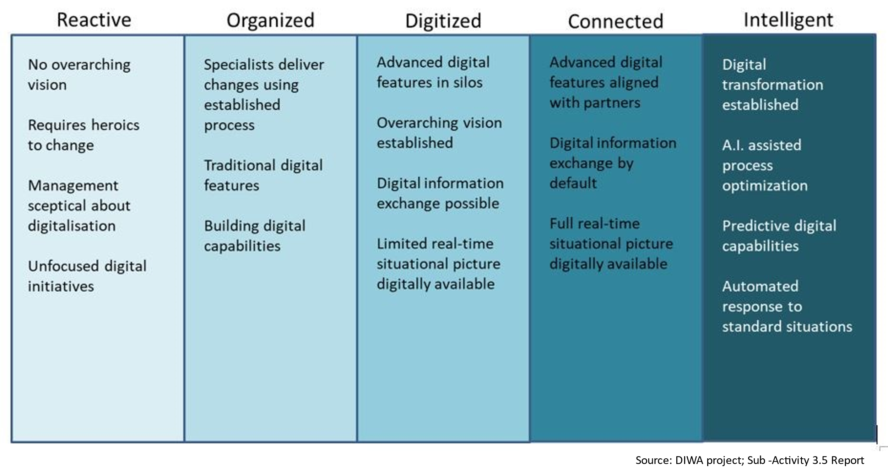
- Five levels of digitalisation maturity model for waterways domain.
The whole maturity model in Figure 1 is set above the purely analogue environment, where voice communication via analogue (radio) communications means and data storage on paper prevail.
The highest maturity level Intelligent assumes the use of artificial intelligence, prediction algorithms and automated responses to standard situations, but is considered a long-term objective, which might not be achievable within a short time frame or with the technologies available within near future. Hence, it is necessary to also use the other maturity levels as intermediate states of the digital transformation. Progression between levels requires that the prerequisites of lower levels are fulfilled, and that the assessment scope is clearly defined. Presently, the maturity levels Reactive and Organised can be frequently found and thus form the baseline, where a limited number of digitalisation processes have partly become effective and form the starting point for any future increase of digitalisation maturity.
The maturity model applies to the entire waterway domain, including vessels, infrastructure, organisations and data (Figure 2).


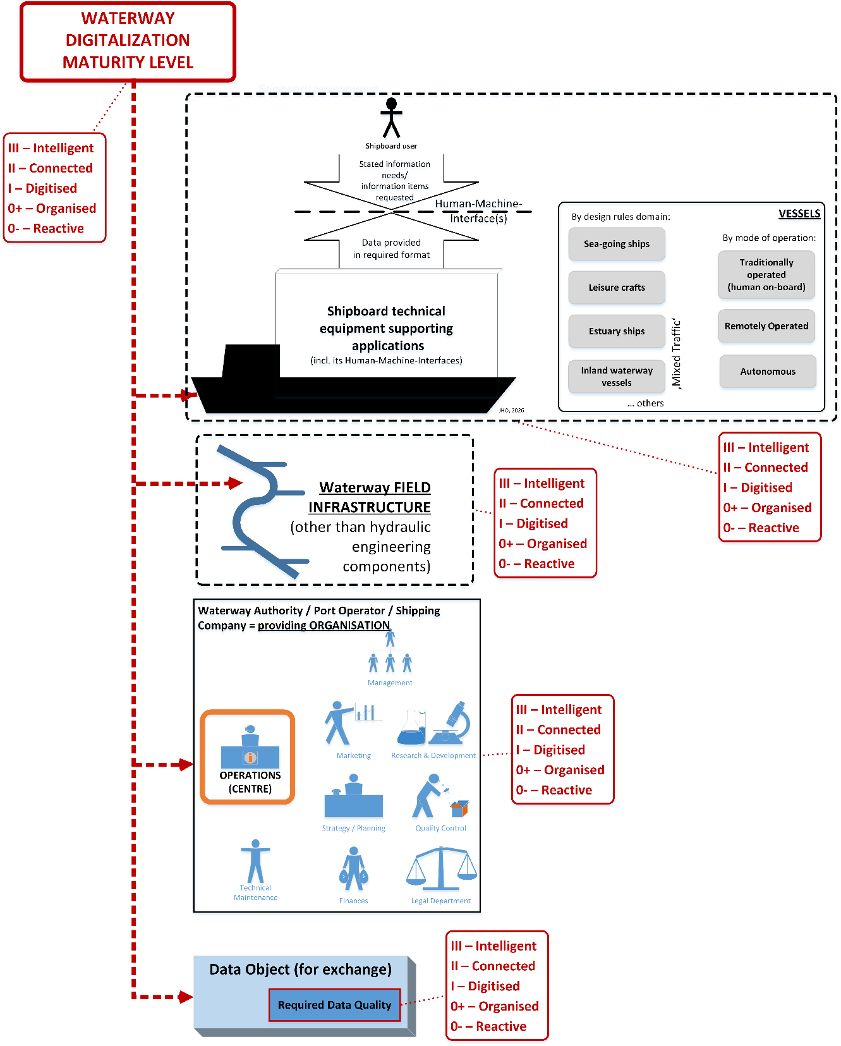
- Digitalisation maturity levels applied to the waterway domain.

Digitalisation challenges

Increased interdependency
Higher levels of digitalisation increase interdependency between systems and actors. This requires unambiguous data models, harmonised interfaces, reliable connectivity and resilient system design.
In contrast to the analogue domain, digital data exchange generally does not allow ambiguities in data object definitions or in the data models governing these objects. To reach maturity level Connected, where digital data exchange is the default mode of operation, relevant regulations, operational procedures, terminology and data models need to be as free of ambiguities as possible.
Another consequence of increasing digitalisation maturity is the growing variety of digital technologies used for data exchange. Data exchange requires a terminal, such as a transceiver, at each end of the communication link. Both terminals must operate in accordance with a predefined set of rules, including data encoding formats, data link protocols and, in the case of radio communication, radio frequency usage rules. By contrast, some technologies, such as radar, do not rely on the cooperation of another entity to perform their function.
To mitigate the risks associated with increased interdependency, certain stand-alone technologies are still needed as fallback arrangements even at high maturity levels.

Match-principle
The Match-principle requires that entities engaged in the same operational relationship operate at compatible digitalisation maturity levels. Mismatches can prevent services from functioning or cause serious operational failures. Such situations may occur, for example, in areas where waterways with different types of service portfolios merge.
This principle is particularly important during implementation and deployment, as digital services do not automatically degrade gracefully. In some cases, this may lead to a sudden drop from the intended maturity level to a very low maturity level. Acceptable mismatches, degradation levels and fallback arrangements should therefore be defined early in the planning phase. The following questions should be considered:
- What digitalisation maturity level match margin would be permissible between specific entities engaged in specific operational relationship(s)?
- What digitalisation maturity level degradations would be permissible under normal operating conditions?
- What fallback arrangements would be permissible or anticipated for exceptional conditions?

Mixed traffic conditions
The mixed traffic scenarios involving different vessel types, automation levels and operating domains present major challenges for digitalisation. Figure 3 illustrates the general categories of mixed traffic. There are specific legal/regulatory bodies defining what a vessel of a certain type and operating domain should consist of and carry, subject to a carriage requirement.
Figure 3 also illustrates the relevant shore entities that are interacting with the mixed traffic. While interaction between these two has been present in the analogue world for long, the projection into the digital domain requires specific attention.

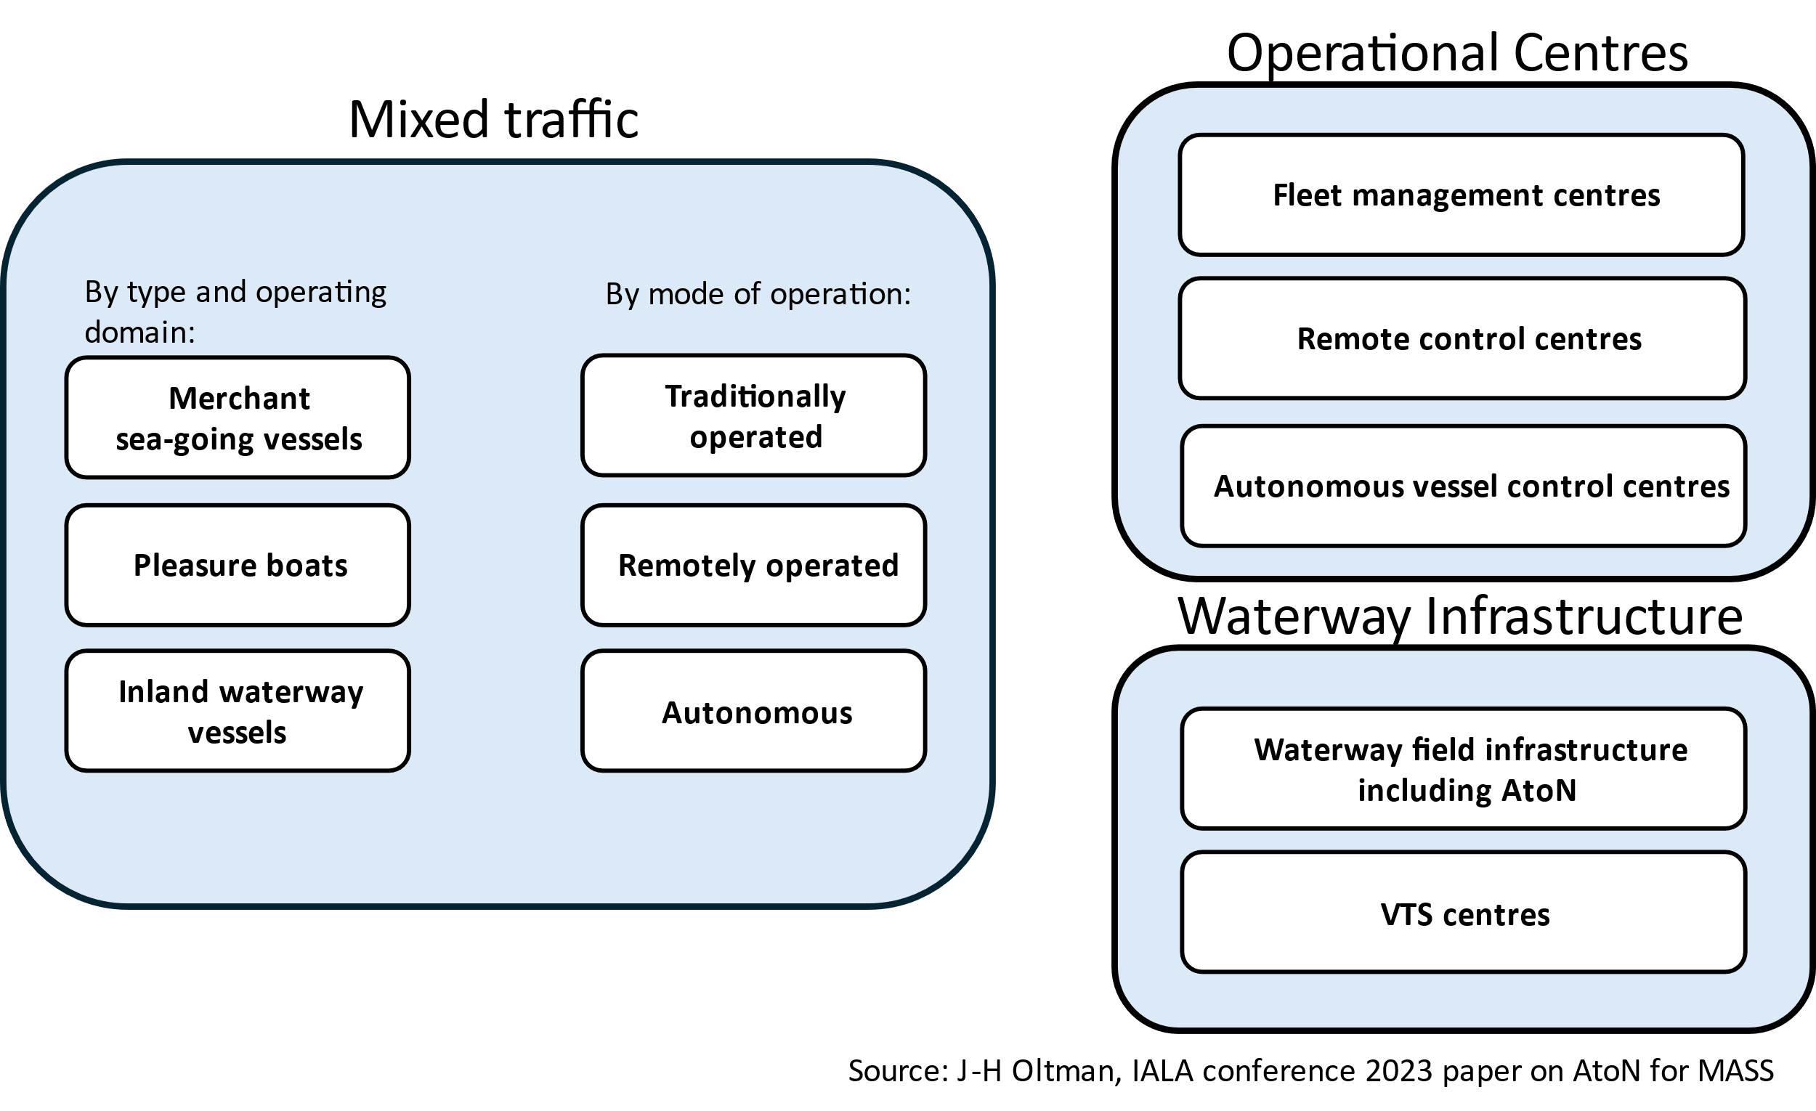
- Mixed traffic, waterway infrastructure (authorities), and operational centres (shipping companies).

Vessel type
The International Maritime Organisation (IMO) can establish mandatory carriage requirements for merchant sea-going vessels (i.e. cargo ships of 500 gross tonnage or over and passenger ships on international voyages) through the International Convention for the Safety of Life at Sea (SOLAS). The Convention specifies minimum standards for the construction, equipment and operation of these ships, thereby harmonising ship capabilities, such as communication equipment, on a global basis.
Carriage requirements for vessels not covered by SOLAS Convention, such as pleasure boats and inland waterway vessels, are regulated at regional or national level, which does not guarantee the same capabilities or global harmonisation as provided by the SOLAS Convention. This creates mixed-traffic situations that must be considered when planning digitalisation in the waterway domain, and in particular in relation to the Match-principle.
In several parts of the world, sea-going vessels frequently operate in inland waterways, for example when approaching ports via estuaries or during canal passages, and inland waterway vessels also operate in coastal waters. While planning the digitalisation of waterways in such areas, it is important to consider developments in the inland waterway domain, as well as the technical requirements applicable to inland waterway vessels. The World Association of Waterborne Transport Infrastructure (PIANC) and United Nations Economic Commission for Europe (UNECE) both work towards harmonisation in the inland waterway domain.

Level of automation
The increasing use of highly automated and even autonomous vessels requires that waterway infrastructure, such as AtoNs, is able to support vessels in mixed traffic environments in which traditionally operated, remotely operated and autonomous vessels coexist. The International Organization for Marine Aids to Navigation (IALA) has closely followed the regulatory work related to Maritime Autonomous Surface Ships (MASS) at the IMO from an early stage.
The key findings of an IALA workshop on "Marine Aids to Navigation in the autonomous world", held in 2021 [7] are highly relevant for the digitalisation of waterways:
- “Marine Aids to Navigation will continue to be essential infrastructure for all degrees of maritime autonomy on vessels and will continue to be required to support safe, efficient and pollution free transits. This includes identifying options for position, navigation and timing (PNT). This may lead to the development of adaptive AtoN to support different degrees of autonomous vessels.
- MASS will require a robust and resilient communication ‘system of systems’ to support complex and vital communication needs, allowing communication between ships, remote control centres, VTS, AtoNs and other elements that may be required in a MASS operating environment.
- All developments in the provision of AtoN to support MASS must consider their role in a mixed maritime environment which includes both conventional vessels and MASS and be fully compatible with both.”
The full autonomy is anticipated to be limited to specific periods or to a defined operational scope, referred to as the Operational Envelope [8]. As part of the contingency response, an autonomous vessel may revert to remote operation or even to traditionally onboard operation by a crew.
Autonomous vessels operate as part of a wider system than traditionally operated vessels, including remote-control or autonomous vessel control centres, which increases connectivity and interoperability requirements. Figure 4 illustrates the additional connectivity requirements introduced by remotely operated and autonomous vessels.

- Communication relationships between shore and ships of different levels of autonomy.

Digital model, shadow and Twin

Overview

A digital model is a digital representation of a physical object. Depending on the level of synchronisation between the digital and physical objects, the digital representation may also be referred to as a digital shadow or a digital twin (Figure 5 [9]).
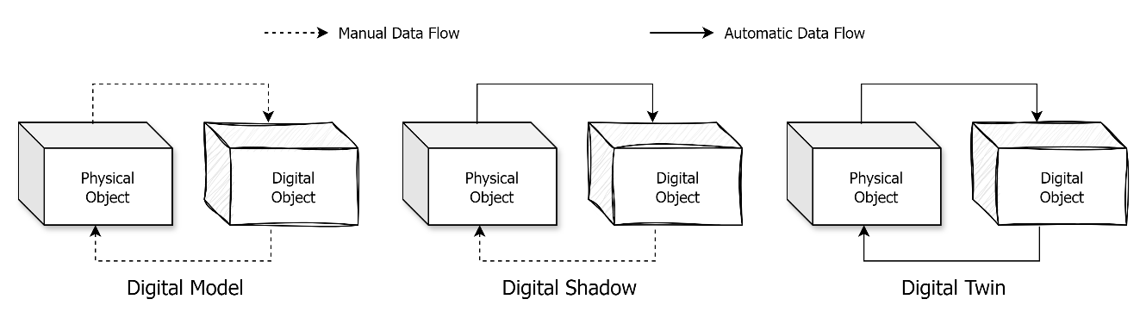
- Digital Model - Digital Shadow – Digital Twin.
A basic digital model of a waterway contains information about the characteristics of the waterway, its infrastructure components, and maintenance events in digital, reusable and preferably standardised format. The model is updated only manually.
A more developed digital model, referred to as digital shadow, adds automatically updated real-time sensor data regarding the condition and status of the infrastructure, environmental conditions, and vessel traffic. It requires appropriate sensors on the physical entities and communication means from them.
The most advanced digital representation, the digital twin, can additionally send automated feedback to physical systems. This requires decision-making algorithms and two-way communication. A digital twin may further be classified as a responsive, adaptive, or intelligent twin based on its features (e.g. simulation and self-learning capabilities).
Frequently synchronised digital models enable for example predictive maintenance, forecasting, proactive traffic management, provision of information and safety related services to vessels and more accurate simulation for waterway design and risk mitigation (Figure 6).
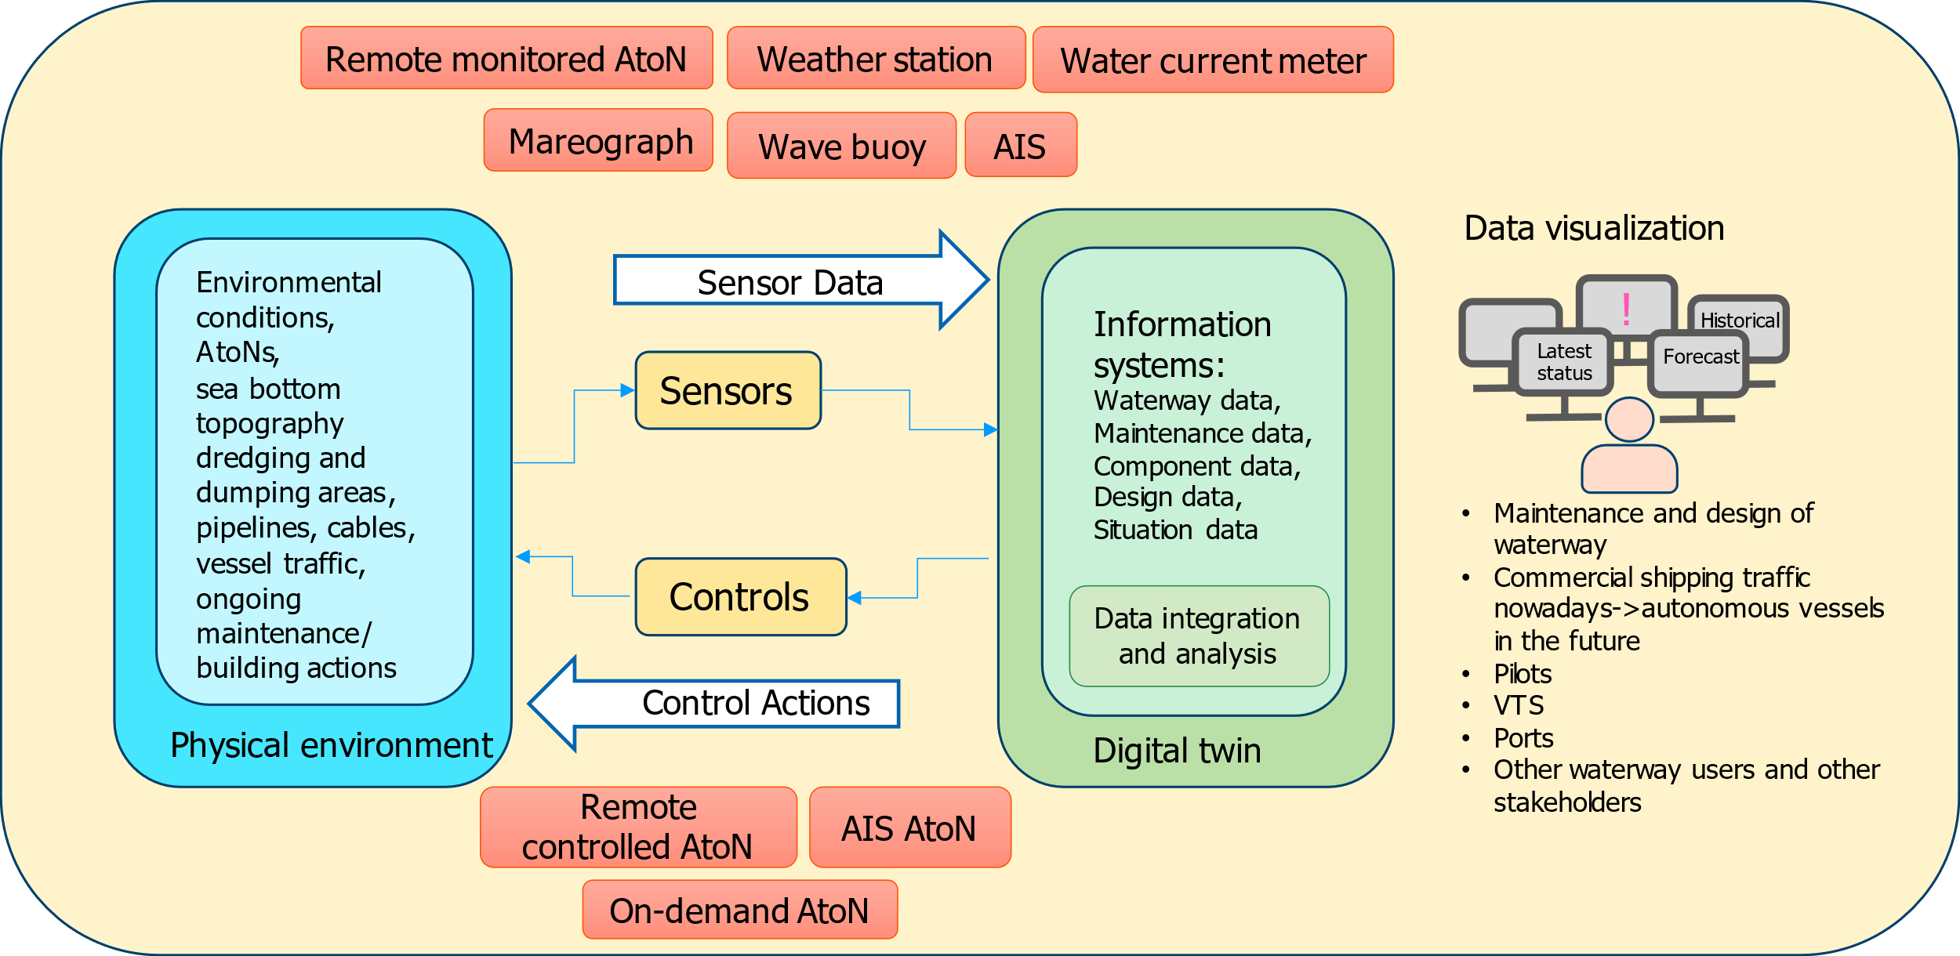
- Digital twin in waterway management.

Development of Digital models

The digital twins are developed progressively from digital models. The process starts with data management planning and Geographic Information System (GIS) based data collection. It advances to the development of digital shadow through the establishment of sensor networks and communication systems that enable the model to be frequently and automatically updated. Full digital twins are created by enabling two-way communication between the model and the physical waterway, integrating sensor data with decision-making algorithms, and allowing automated feedback to the physical world. Digital twins may also include forecasting and simulation capabilities.
The process may include the following phases and actions:
- Digital model
- Defining planned uses of the model and identification of required data elements.
- Determining required versus available data elements and planning how to fill the gaps.
- Developing and deploying a data management plan.
- Developing an information system (e.g. GIS) to merge and display information of various elements of waterways.
- Digital shadow
- Establishing a real-time sensor network to monitor waterway infrastructure, environmental conditions, and traffic.
- Establishing the required communication infrastructure to connect to the sensor network.
- Creating the required data layers for visualisation and monitoring of sensor data in the digital environment.
- Digital twin
Responsive
- Developing decision-making algorithms to provide automated feedback from digital twin to the physical environment based on sensor information.
- Establishing two-way communication between the digital twin and physical environment, and the installing required physical control equipment to enable the automatic feedback functions.
Adaptive
- Developing forecasting models to predict the behaviour of different phenomena in the physical waterway.
Intelligent
- Developing self-learning capabilities and automated decision-making based on it.

Data management plan
Identification of relevant data for a digital model depends on the intended use of the model and should be decided during the planning process. For example, waterway modelling may be two-dimensional, three-dimensional, or multidimensional. Two-dimensional (2D) models, such as Electronic Navigational Charts (ENCs), use objects with associated properties to portray the real waterway virtually, but they cannot reproduce the real three-dimensional environment. Three-dimensional (3D) models can realistically represent the above- and below-water physical environment, including buildings, bridges, AtoNs, seabed, and terrain, using high-resolution spatial data; however, they do not show virtual navigation-related areas such as anchorage areas or the properties of the structures. Multidimensional models integrate 2D and 3D data to deliver accurate, multi-resolution geospatial representation.
The information presented in Table 1 may be considered to form the baseline requirements for data elements needed to create a digital waterway model. However, additional data elements may be required depending on operational needs.
- Baseline information for digital waterway models.
Type of model | Information | Example of parameters
Digital model | Waterway geometries | fairway areas, navigation lines, leading lines, turning circles
Digital model | Depth information | numbers, contours, areas, tidal windows
Digital model | AtoN information | location, properties, physical condition, status (when updated automatically forms part of shadow or twin)
Digital model | Specific areas | anchorage, special, prohibited, VTS, speed limits
Digital model | Specific points | VTS reporting, pilot boarding
Digital shadow/twin | Environmental conditions | water level, salinity, wave height, sea state, current, temperature, wind, visibility, pressure
Digital shadow/twin | Traffic information | vessel identification and position, traffic allocation slots

A digital twin relies on data from multiple static and dynamic sources with varying update rates. A data management plan is an essential prerequisite for the construction of digital twins. It defines the criteria for data quality and thus determines the level of accuracy of the digital twin that can be achieved. A data management plan may, for example, include the following rules for data, its flow, and processing:
- Data are stored in information systems and data flows are automated (processes do not include manual work).
- Position information includes x, y and z-coordinates.
- Objects have geometry (e.g. point, line, polygon).
- Data processing is documented.
- Data quality is known and documented.
- The origin of data is known and preferably authenticated.
- Data are structured and data models are described or follow existing standards (including semantics, data types, accepted values, etc.).
- Data include a timestamp, and history is maintained and not overwritten.
- Data is available through documented and standardised interface.
The digital twin introduces new possibilities for the use of data analytics tools, machine learning, and artificial intelligence. An advanced digital twin may autonomously combine and analyse data and initiate actions based on the results of these analyses. This increases the need to strongly secure the quality and reliability of data (e.g. accuracy, integrity, immutability and origin) at every stage of the data life cycle and during data processing and exchanging.
Regardless of the status of data (e.g. in transit, at rest or being processed), they need to be secured against cyber-attacks. Guideline G1182, Cyber security specifics from an IALA perspective, provides comprehensive guidance on possible measures to mitigate cyber security risks in the IALA domain.

Information presentation system
A presentation system is required to display the digital data entities that describe the real waterway in digital form. Such presentation systems support functions such as waterway management and maintenance, traffic monitoring, and information dissemination, and enable efficient visualisation of static and dynamic data entities.
Each function has its own priorities and visualisation needs, but common presentation interface features may include the following: a user-friendly interface, ease of operation, efficiency and stability, and scalability.

Sensor network
Establishing a real-time sensor network to monitor waterway infrastructure, environmental conditions, and traffic is required in order to keep the waterway digital model up to date.
In many cases, sensor networks already exist to cover at least part of the waterways. Systems for the remote monitoring of AtoNs (e.g. status, position) are mature and widely used. Integrating data from these systems into the digital model may require the development of new information exchange interfaces, but solutions for sensors and connectivity may already exist. The same applies to traffic information in Vessel Traffic Service (VTS) areas, where traffic monitoring is handled by VTS sensor networks. Again, there may be a need to develop interfaces for data exchange, but the required sensor networks and connectivity are already in place.
There are few fixed objects in the sea, especially in coastal waterways, apart from marine AtoNs. Therefore, marine AtoNs are ideal platforms for deploying additional sensor networks to monitor environmental conditions and traffic situation. AtoNs are also generally located in important water areas. While selecting location for additional sensors, for example, the following areas may be preferred:
- Areas with dense traffic
- Important ports and waterways
- Waterway entrances
- Accident prone areas
- Narrow waterways
- Turning points
- Reefs, shoals and other areas with variable currents
- Areas requiring environmental monitoring
- Sensitive ecological environments
The final selection of sensor locations should balance operational requirements (e.g. area covered, reporting frequency) with the costs of deployment and maintenance (e.g. availability of power supply and connectivity at reasonable cost).

Connectivity
There is no requirement to use any specific globally harmonised communication system for transporting data from sensors to shore-based systems. The data can be transferred trough any communication link that can meet the requirements for availability, reliability, data rate, capacity, latency and security. Most likely, no single communication system is optimal for all locations and sensor types. The same applies to communication links used for automated feedback from digital twin to control equipment in the physical waterway.
Candidate communication systems include IMT (e.g. 4G, 5G), VDES, Wi-Fi, satellite networks (e.g. Iridium), and low-power wide-area networks (e.g. LoRaWAN, Sigfox).
The Guideline G1179, an Introduction to the Internet of Things from an IALA Perspective, provides information on communication systems for IoT that can be used to support the communication needs of digital twins of a waterway.

Usage
Digital models may support authorities in waterway maintenance, planning, and traffic management by providing real-time information on infrastructure status, environmental conditions, and vessel traffic. They enable predictive maintenance, forecasting, proactive traffic management, and more accurate simulation for waterway design and risk mitigation. These capabilities support decision-making. The real-time information from waterway may further be passed on to vessels to enhance the safety and efficiency of navigation.
Support to authorities for decision-making may include:
- For management departments in charge of ports, waterways, and AtoNs, the operation status of various types of AtoN infrastructure may be monitored in real time through telemetry, remote control, CCTV, etc. At the same time, the management of different types of AtoN infrastructure may be supported through the application of specific digital models.
- For management departments in charge of ports, waterways, and AtoNs, conclusions addressing different demands, as well as data support, may be derived through big data processing and analysis based on various types of information and statistics obtained, in order to assist decision-making in waterway planning, design, maintenance, and the allocation of AtoNs. Simulations help to identify risks, plan mitigation measures (e.g. appropriate channel layout and placement of AtoNs), and evaluate the mitigation results before implementation. Comprehensive guidance on the use of different simulation tools is available in Guideline G1058, the Use of Simulation as a Tool for Waterway Design and AtoN Planning.
- For pilot departments, the optimal boarding time and boarding location may be determined based on real-time wind, wave, and current data in order to effectively reduce boarding risk.
- For traffic management, the optimal voyage plans may be developed through technical processing of dynamic data from waterways, together with comprehensive consideration of factors such as anchorage, ports, vessel traffic, and weather, to improve the utilization efficiency of anchorages and terminals. Furthermore, in emergency situations at sea, relevant information may be obtained immediately, and emergency response may be conducted in a timely manner.
Support to vessels may include:
- Real-time and accurate anchorage information, including anchorage operation information, to help ships better arrange voyage plans.
- Real-time and accurate hydrological and meteorological information to assist ships in making better operational decisions and reducing navigation risks.
- Optimal routing for ships based on real-time ship traffic, hydrological and meteorological information, anchorage etc., in order to improve navigational efficiency and reduce costs for the shipping industry.

Practical deployment examples

Vessel traffic management
Creating a digital twin of a waterway can significantly enhance vessel traffic management, as it enables the safe simulation of various scenarios involving different types of vessels navigating the waterway. This may include the selection of hydrological and weather conditions and traffic scenarios, covering both routine and emergency situations. A digital twin is especially valuable during the construction or renovation of a waterway, as it enables the simulation and analysis of vessel traffic management at early design stages.
For existing waterways, a digital twin also serves as a valuable training tool. It allows port personnel, such as pilots or VTS operators, to simulate and practice managing vessel traffic in a safe environment.

Remotely monitored floating visual Aids
Systems for remotely monitoring the status of floating AtoNs and their equipment has been widely used over a decade now. These systems provide data flow from physical object (floating AtoN) to a digital monitoring system and may also prove means to remotely control (manually) the status and configuration of the physical object, thus creating a digital shadow (Figure 7). The digital shadow in this case is limited to the status of AtoN and its equipment, excluding for example the physical condition of the AtoN structures. This type of digital shadow of an AtoN is updated frequently but usually not continuously due to the energy and data link limitations. The Guideline G1008, on Remote Control and Monitoring of Marine Aids to Navigation, gives extensive introduction on remote control and monitoring of marine AtoNs
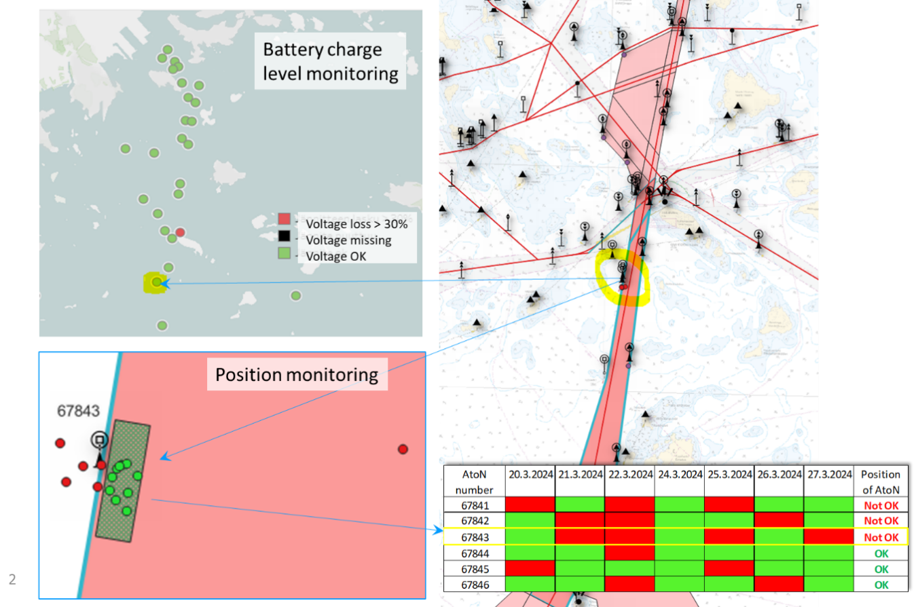
- Example of AtoN remote monitoring information.

AtoN on-demand
The AtoN on-demand concept opens possibilities for upgrading the AtoN digital shadow further into a responsive digital twin. The AtoN on-demand concept has been introduced related to the use of occasional lights in low traffic areas and the possible need to increase intensity of AtoN lights in poor visibility conditions. This technology is described in more detail in Guideline G1038 on Methods and Ambient Light Levels for the Activation of AtoN Lights. Activation method for an on-demand AtoN can be automated based on for example Automatic Identification System (AIS) information and/or information from visibility sensors (Figure 8) [10]. The automated on-demand AtoN will have automatic bi-directional data flow between physical objects and sensors in the waterway (i.e. AtoN, AIS, visibility sensors) and its digital model thus it can be seen to form a limited scale digital twin.
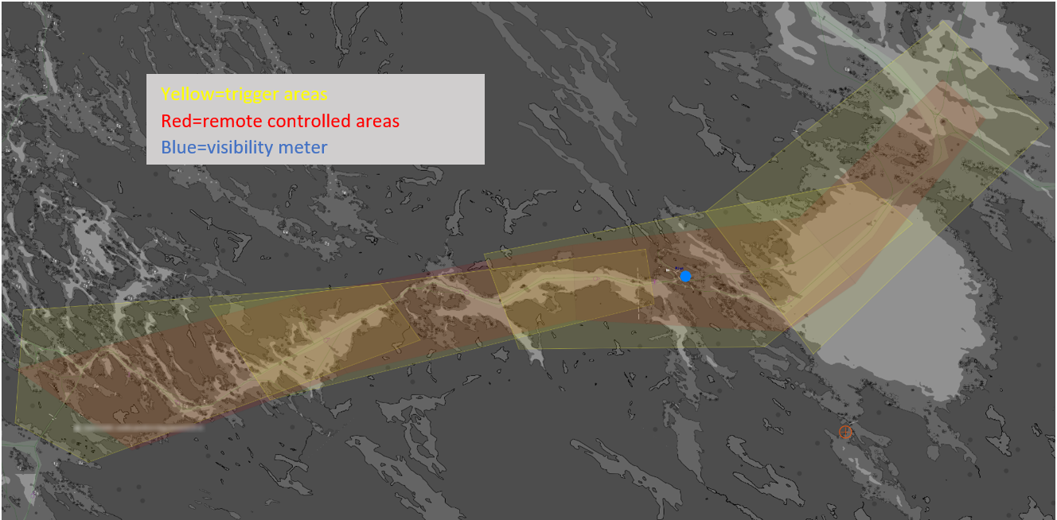
- Example of an on-demand AtoN used for increasing the intensity of AtoN lights based on traffic information from AIS (yellow trigger areas) and prevailing visibility (blue visibility meter).

Digital Services for navigation

Overview

Provision of digital services to individual vessels, to specific types of vessels, and/or to vessel traffic at large is a central part of waterway digitalisation. Some digital services may require bidirectional interaction with vessels, while others may require the availability of a real-time digital model, shadow, or even a digital twin of the waterway.
Internationally harmonised or standardised digital services would enable broad participation in a traditionally open navigation system. As an outcome of its e-navigation strategy [11], the IMO has defined a set of digital services that operate within an overarching architectural framework, called Overarching e-Navigation Architecture. IALA has also defined digital services in support of IMO.
It should be noted that digital services are not limited to maritime use but extend to mixed-traffic areas and inland waterways through systems such as River Information Services (RIS).

Development of digital maritime services

The preparatory steps required to implement digital services include identifying operational needs, defining information exchange requirements (e.g. latency, security), selecting suitable communication methods (e.g. IP-based or specialized radio communications, broadcast or bi-directional), choosing harmonised data formats such as S-100, and planning communication infrastructure based on radio coverage and system selection.
The preparations for the provision of digital services to vessels in a waterway may, for example, include the following steps:
- Identification of operational requirements
- Information exchange needs between shore and ship
- Requirements for latency, security etc
- Identification of information exchange methods
- IP based and/or specialized radio communication systems
- Broadcast, addressed, and/or bi-directional communication modes
- S-100 and/or other harmonized data formats
- Required additional waterway communication infrastructure based on radio coverage analysis
- Deployment of new digital services
- New communication infrastructure if required
- New data products and technical services

Operational requirements
The IMO has defined 15 standardized operational maritime services under the e-navigation framework. These cover key operational services such as vessel traffic and AtoN services, nautical charts, maritime safety information, meteorological and hydrographic information, pilotage, port support, and search and rescue.
PIANC has, in analogy with IMO, identified a set of operational use cases with related services to support safe, secure, efficient and environmentally friendly inland navigation.
Administrations may utilise user consultation together with the harmonised operational service definitions of the IMO and PIANC when identifying the requirements for digital services for different waterway areas.

Maritime services defined by IMO
IMO Circular letter MSC.1/Circ.1610, adopted by the IMO Maritime Safety Committee at its 101st session and amended in June 2024 [12], describes 15 types of Maritime Services in the context of e-navigation (Table 2).
- Maritime Services in the Context of e-Navigation.
Maritime Service ID | Description
MS 1 | Vessel traffic service
MS 2 | Aids to navigation service
MS 3 | (Reserved for future use)
MS 4 | Port support service
MS 5 | Maritime safety information service
MS 6 | Pilotage service
MS 7 | Tug service
MS 8 | Vessel shore reporting
MS 9 | Telemedical assistance service
MS 10 | Maritime assistance service
MS 11 | Nautical chart service
MS 12 | Nautical publications service
MS 13 | Ice navigation service
MS 14 | Meteorological information service
MS 15 | Real-time hydrographic and environmental information services
MS 16 | Search and rescue service

Examples of Maritime Services that rely on digital model of waterways include the AtoN services, Maritime Safety Information (MSI) services, and hydrographic and environmental information services.
IALA defines an AtoN as a device, system, or service, external to vessels, designed and operated to enhance safe and efficient navigation of individual vessels and/or vessel traffic. The purpose of the AtoN service, Maritime Service 2, is to provide information not available on the nautical charts (e.g. new hazards, temporary shipping lanes, temporary areas to avoid, hydrological changes, ice areas) and to provide real-time Position, Navigation, and Timing (PNT) information and PNT integrity information.
The MSI service, Maritime Service 5, is an internationally and nationally coordinated broadcast network containing notices to mariners, weather warnings, weather forecasts, and other emergency safety information.
Water level information, included in Maritime Service 15, is essential for determining under-keel clearance required for safe navigation. Forecast and real-time water level information are important for applications such as route planning, port entry and tidal prediction. Real-time tide and water level information can be used for activities such as situational awareness, hazard avoidance, installation of offshore renewable energy facilities, and route monitoring.

Inland waterway services defined by PIANC
PIANC has, in analogy with IMO, identified a set of operational use cases with related services to support safe, secure, efficient and environmentally friendly inland navigation [13]. The identified services are dived in two categories: services related to traffic and services related to transport in general. The identified services are introduced in Table 3 below.
- Operational River Information Services (RIS) defined by PIANC.
Operational service | Description
Traffic related
Fairway information Services (FIS) | Supporting planning, executing and monitoring the voyage. (e.g. geographical, hydrological and administrative information regarding the waterway and its infrastructure).
Traffic information Services (TIS) | Supporting the safety and efficiency of traffic and navigation on inland waterways. (e.g. vessel positions, specific vessel information, types of cargo).
Information to support Traffic Management (TM) | Supporting VTS, lock and bridge management and traffic planning.
Information to support Calamity Abatement (CAS) | Supporting actions necessary to limit the consequences of calamity, accidents and incidents.
Transport related
Information to support Transport Logistics (ITL) | Supporting transport logistic processes in inland navigation (e.g. voyage planning, transport management, port and terminal management, cargo and fleet management).
Information to support Law Compliance (ILC) | Facilitating legal compliance for the waterway users and supporting the relevant agencies responsible for inland navigation law enforcement.
Information to support Statistics (ST) | Supporting statistical processes (e.g. information on traffic and transport in inland navigation).
Information for Waterway Charges and Harbour Dues (CHD) | Facilitating the calculation and collection of waterway charges and harbour dues.

Information exchange methods
The Universal Hydrographic Data Model, S-100, developed by International Hydrological Organizations (IHO), has been approved as the baseline data model for the implementation of IMO´s e-navigation strategy [14]. It should be noted that IMO has also previously defined a group of Application Specific Messages (ASM) for AIS and recommended them for broad international use [15]. These messages can deliver limited amounts of safety related information, such as areal notices, meteorological and hydrographic data, in standardized data format.

S-100 data products and technical services
Maritime digital services, including the 15 maritime services defined by IMO (Table 2), are based on exchange of standardized data products via technical interfaces and communication links in a standardised and structured manner. Figure 9 illustrates the relationship between these elements within the S-100 domain.
S-100 data model specifications enable the digital representation of navigable waters, including, for example, detailed seabed topography, ocean currents, weather forecasts, local tides, water level simulations, navigational warnings, and harbour information. Information is transferred to vessels via technical service interfaces and appropriate communication links. A technical service may provide information based on multiple data models and a single Maritime Service may use multiple technical services.

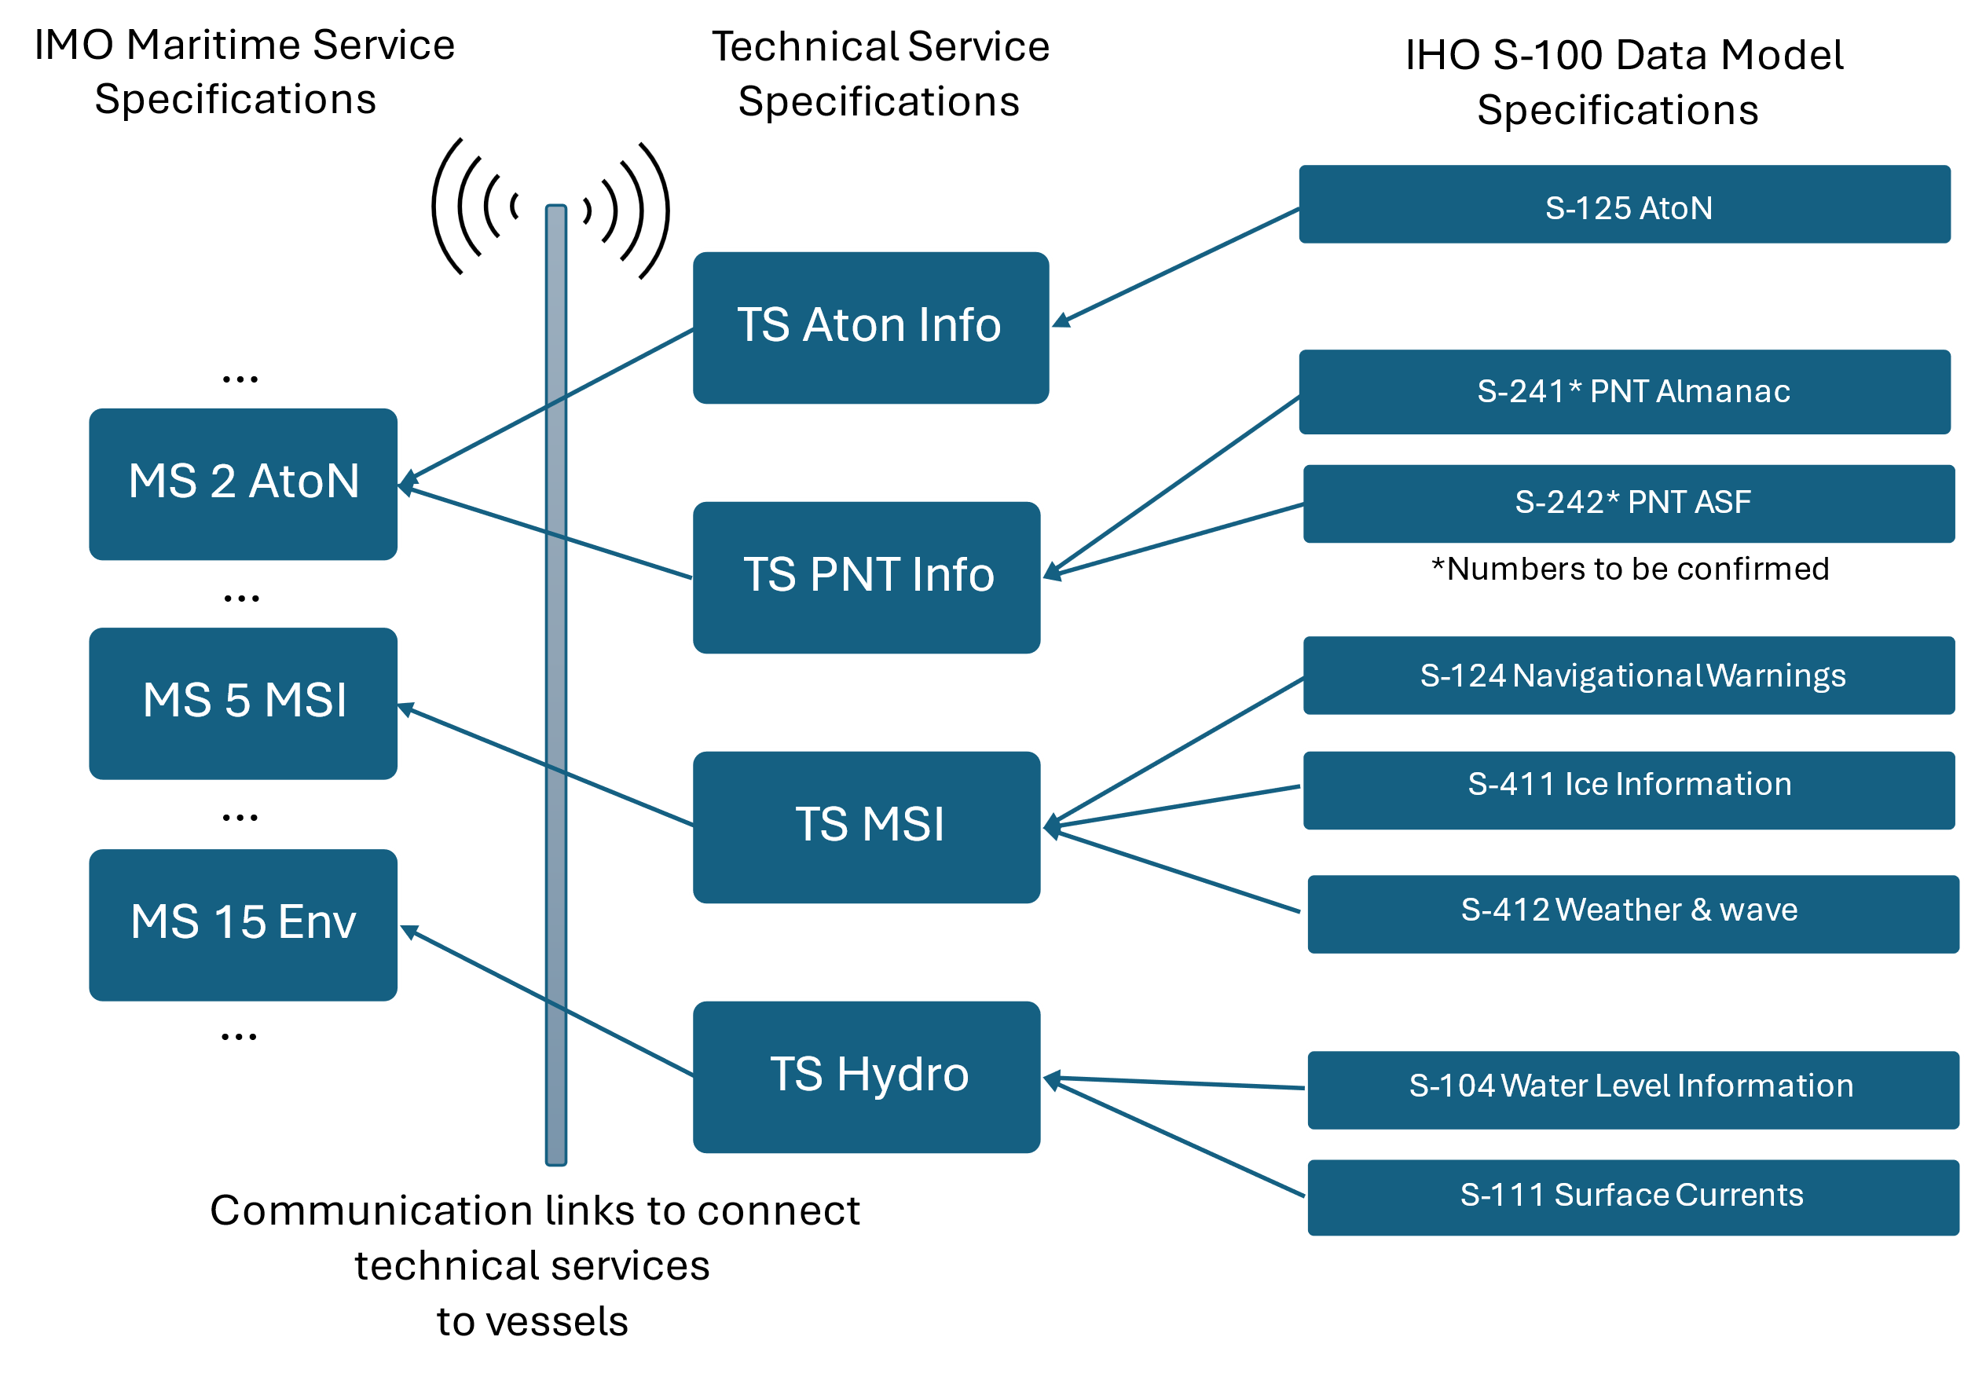
- An Example of relationships between specifications of IMO Maritime Services, technical services, S-100 data models/product specifications, and connectivity.
The IHO has primary responsibility for the development and maintenance of S-100 data model specifications used for vessel route planning and monitoring. Other supporting data model specifications are being developed by various international organisations (Table 4). From 2026 onwards, S-100 data products may be used in vessel Electronic Chart Display and Information System (ECDIS) equipment. The IHO has identified the first set of products that will be permitted to be displayed in ECDIS. These five products are indicated in Table 4 in bold.
S-100 products require different update intervals depending on the type of information they contain. Many new S-100 products will presumably be distributed via the existing Regional ENC Coordinating Centres (RENC) in the same manner as current ENC products. However, some S-100 products will carry near real-time information, and alternative distribution channels need to be considered. IALA has been actively involved in developing technical service specifications for interfacing frequently updated, near real-time S-100 data products, such as the S-125 Marine AtoN.
- List of known IHO S-100 based product specifications.
Responsible organization | Number range | Product specifications
International Hydrographic Organization (IHO) | 101-199 | S-101 Electronic Navigational Chart (ENC)  S-102 Bathymetric Surface  S-103 Sub-surface Navigation  S-104 Water Level Information for Surface Navigation  S-111 Surface Currents  S-112 Open - (See Decision HSSC9/38)  S-121 Maritime Limits and Boundaries  S-122 Marine Protected Areas  S-123 Marine Radio Services  S-124 Navigational Warnings  S-125 Marine Aids to Navigation (AtoN)  S-126 Marine Physical Environment  S-127 Marine Traffic Management  S-128 Catalogue of Nautical Products  S-129 Under Keel Clearance Management (UKCM)  S-130 Polygonal Demarcations of Global Sea Areas  S-131 Marine Harbour Infrastructure  S-164 IHO Test Data Sets for S-100 ECDIS
International Organization for Marine Aids to Navigation (IALA) | 201-299 | S-201 Aids to Navigation Information  S-210 Inter-VTS Exchange Format  S-211 Port Call Message Format  S-212 VTS Digital Service  S-230 Application Specific Messages  S-240 DGNSS Station Almanac  S-245 eLoran ASF Data  S-246 eLoran Station Almanac  S-247 Differential eLoran Reference Station Almanac
Intergovernmental Oceanographic Commission (IOC) | 301-399 | None proposed yet
Inland ENC Harmonization Group (IEHG) | 401-402 | S-401 IEHG Inland ENC  S-402 IEHG Bathymetric Inland ENC
WMO Service Commission (SERCOM) | 411-414 | S-411 Ice Information  S-412 Weather and Wave Hazards  S-413 Weather and Wave Conditions  S-414 Weather and Wave Observations
International Electrotechnical Commission - TC80 (IEC-TC80) | 421-430 | S-421 Route Plan
NATO Geospatial Maritime Working Group (GMWG) for Additional Military Layers (AML) | 501-525 | None proposed yet

Application Specific Messages
In addition to S-100 products transmitted via IP connections, e-navigation services can be delivered to ships through the fixed format messages transmitted via the subsystems of VDES, AIS and ASM, operating in the maritime VHF band. IMO has defined the set of internationally harmonised message types, presented in Table 5; messages shown in bold are available for transmitting information to vessels. IALA maintains an additional list of regional message types on its website (https://www.iala.int/asm/).
- List of Application Specific Messages approved by IMO.
Functional Identification | Message name | Description
16 | Number of persons on board | Allows a vessel to report the number of persons on board when requested.
17 | VTS-generated/synthetic targets | Allows to transmit VTS or other types of synthetic targets to vessels.
18 | Clearance time to enter port | Allows to provide specific vessels with information on the granted port to call and time to enter.
19 | Marine traffic signal | Allows to provide information on a signal station and status of the control signal at the entrance of a harbour or channel where the shipping direction is controlled so that the traffic flow be kept in order.
20 | Berthing data | Allows to provide information on the ship's berth.
21 | Weather observation report from ship | Allows a vessel to provide weather observations to shore authorities.
22 | Area notice – broadcast | Allows to provide dynamic information concerning a specified geographic area, polyline or positions to vessels (e.g. cautions, environmental cautions, restrictions, anchorage areas, distress, instructions, information, reports, routes).
23 | Area notice – addressed | As above but to addressed vessels.
24 | Extended ship static and voyage-related data | Allows to obtain additional extended and static voyage-related data from vessels when requested.
25 | Dangerous cargo indication | Allows the ship to report the general categories on dangerous cargoes when requested.
26 | Environmental | Allows to provide environmental information from sensor reports.
27 | Route information – broadcast | Allows the communication of pertinent vessel routing information to vessels.
28 | Route information – addressed | As above but to addressed vessels.
29 | Text description – broadcast | Allows to provide a text description in combination with another Application-Specific Message.
30 | Text description – addressed | As above but to addressed vessels.
31 | Meteorological and Hydrographic data | Allows the distribution of meteorological and hydrographic information (e.g. water level, currents).
32 | Tidal window | Allows to inform vessels about tidal windows which allow a vessel the safe passage of a fairway

Connectivity
The ability to provide digital services to vessels is strongly dependent on the availability of adequate connectivity between vessels and shore. IALA has published comprehensive guidance on communication technologies for maritime purposes in the MARCOM manual. It provides information on current, developing and future communication systems supporting communication needs between vessels and shore.
As the provision of digital services increase, legacy maritime communication systems (e.g. AIS, GMDSS) will need to be complemented by other communication systems that can better support the transmission of larger volumes of data and IP based data (e.g. VDE, satellite communication systems, IMT). However, it should be noted that only communication systems with mandatory carriage requirements can guarantee extensive connectivity to vessels in a waterway.

Maturity of digital maritime services

The aviation domain has long defined categories for types of airport runways based on level of approach and landing capabilities provided to aircraft. This concept could be adapted to the waterway domain. The levels defined in the aviation domain are presented in Table 6 [16].
- Airport runway service categories.
Level | Description
Non- precision Approach Runway | A runway served by visual aids and at least one non-visual aid, intended for landing operations following an instrument approach operation with a minimum descent height or decision height at or above 75 m (250 ft).
Precision Approach Runway, CAT I | A runway served by visual aids and at least one non-visual aid, intended for landing following an instrument approach operation with a decision height not lower than 60 m (200 ft) and with either a visibility not less than 800 m or a runway visual range not less than 550 m.
Precision Approach Runway, CAT II | A runway served by visual aids and at least one non-visual aid, intended for landing operations following an instrument approach operation with a decision height lower than 60 m (200 ft), but not lower than 30 m (100 ft) and a runway visual range not less than 300 m.
Precision Approach Runway, CAT III | A runway served by visual aids and at least one non-visual aid, intended for landing operations following instrument approach operation with a decision height lower than 30 m (100 ft) or no decision height and a runway visual range less than 300 m or no runway visual range limitations.

By analogy, the role of a runway in aviation is represented in the maritime domain by the waterway. Digital services may be provided to shipping while vessels are transiting through the waterway to a port. In the aviation domain, these electronic services consist of the precision instrument approach and landing transmissions provided by the Instrument Landing Systems (ILS) at airports.
Different levels of service provision in the waterway domain reflect, again by analogy, the varying requirements of shipping for support in different types of waterways. In aviation, these different needs are defined by the vertical and forward visual ranges available for landing decision-making; in the waterway domain, this translates into different sets of digital services, which in turn may indicate different degrees of digital maturity.
The maturity of digital services in the waterway domain could, for example, be classified using the levels shown Table 7.
- Digital maturity levels of navigational services.
Service level 1 | Basic AtoN services, no integrity information | Visual AtoNs and radar navigation aids, GNSS
Service level 2 | AtoN integrity information provided | Broadcasted AtoN status, GNSS integrity and augmentation, environmental information, etc.
Service level 3 | AtoN services adapted to existing conditions | AtoNs are manually adapted based on waterway conditions (e.g. visibility, traffic, water level)
Service level 4 | AtoN services adapted to individual user needs | Individualised services are provided to vessels
Service level 5 | Adaptation of services fully automatized | AtoNs are automatically adapted based on waterway conditions and individualized services are provided to vessels automatically.

Practical deployment examples

Route exchange service
[Some examples to be added]

Maritime Safety Information service
Finland launched a new navigational warning service in early 2026, based on the S-124 product specification and service specification. The service enables the navigational warnings to be display directly in the ECDIS (Figure 10).
The new technical service for navigational warnings has been integrated with the MSI database and generates the S-124 datasets. Data distribution takes place over IP using the Maritime Connectivity Platform (MCP) and the secure, encrypted SECOM protocol. The service can use VDES or any available onboard IP connection (e.g. 4G, 5G or satellite communications).

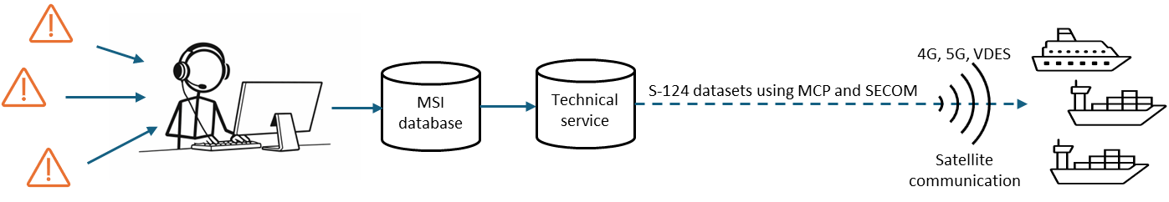
- S-124 based Maritime Safety Information service.
The new service is not yet an officially SOLAS/GMDSS-approved method for transmitting warnings. At this stage, it is essentially a value-added service that provides S-124 data to support ECDIS manufacturers' development work. The legacy distribution methods - NAVTEX and VHF - will most likely remain in parallel for a long time.

Architectures for Digitalisation of waterways

Overview

The aim of any architecture is to structure the different entities within its scope into a contextual framework. Architectures help to understand processes and data flows and to identify possible gaps. Architecture thus provides both structure and context. Different architectural models highlight different points of view and thereby complement each other. The need for architecture increases with the level of digitalisation and the resulting increase of cooperative interactions. This section introduces a few architecture frameworks that may support the digitalisation of waterways by providing tools to analyse information exchange needs and possible solutions (Table 8)
- Different architecture frameworks.
Architecture | Description
Overarching e-navigation architecture | A high-level model that describes how maritime information and data are structured, exchanged, and presented between ships and shore to enable harmonized, safe, and efficient e-navigation. It describes the different actors and their information needs on board and ashore, as well as how the information is delivered between them.
Shipboard navigation system architecture | Supplements the overarching e-navigation architecture by presenting shipboard information exchange systems at a more detailed level. It supports modular design and standardized interfaces.
Common shore-based system architecture | Supplements the overarching e-navigation architecture by presenting shore-based information exchange systems at a more detailed level. It supports modular design and standardized interfaces.
Maritime system interconnection architecture | Identifies communication needs between vessels, waterway infrastructure and shore users in all combinations. It helps to identify optimal combinations of technologies, assess versatility and fallback paths, and harmonise specifications and standards across stakeholders to support complex cooperative communication relationships.
Maritime Architecture Framework | A three‑dimensional model, referred to as the cube, that visualises three architectural aspects (hierarchical, topological and interoperability) and helps to identify digitalisation interoperability issues, gaps, and overlaps.

overarching e-navigation architecture

The overarching maritime architecture (Figure 11) was developed within the IMO’s e-navigation initiative [14], a global maritime digitalisation initiative. It is a high-level reference model that explains how maritime information and data are created, exchanged, and used between vessels and shore-based authorities within the e-navigation concept. It is based on a datalink communications architecture that includes mobile units (e.g. vessels), infrastructure (e.g. shore-side systems), and the data links between them.
The model helps to describe separately the information needs of different actors and the corresponding information delivery channels (i.e. technical services and communication links). By distinguishing information needs from the underlying technical systems, it allows systems to evolve without changing the user experience.
The overarching e-navigation architecture helps to ensure that the right information reaches the right users at the right time, supports system interoperability, and facilitates the development of harmonised standards and regulations.
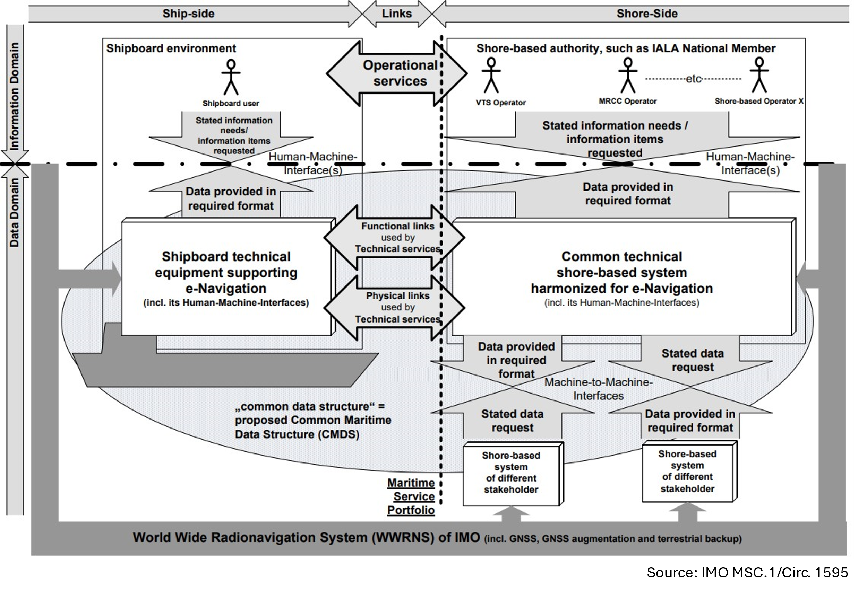
- Overarching e-navigation architecture
The two boxes in Figure 11, representing shipboard technical equipment and shore-based systems, contain more detailed technical information on communication systems and data processing. These are described by the shipboard navigation system architecture and common shore-based system architecture, respectively.

Shipboard navigation system architecture
The generic shipboard navigation system architecture (Figure 12) provides a view on shipboard sensors, data processing, presentation and communications systems. It is structured hierarchically into three functional layers in the vertical dimension, which, from bottom to top, are:
- Sensor / Source layer: Includes shipboard sensors, the pre-processing entities for their data, and radio communication front ends to the physical radio links. This layer provides the technical interface to the physical and operational environment of the ship.
- Data Processing layer: Specialised in processing, storing, and retrieving data relevant to vessel navigation, including the selection, filtering, and routing of available physical radio communication links, as well as the handling of all relevant alerts from navigational systems and other bridge equipment, as received from Bridge Alert Management (BAM).
- Operational layer: Provides the human-machine interface (HMI) to the bridge team to support their navigational tasks as indicated.
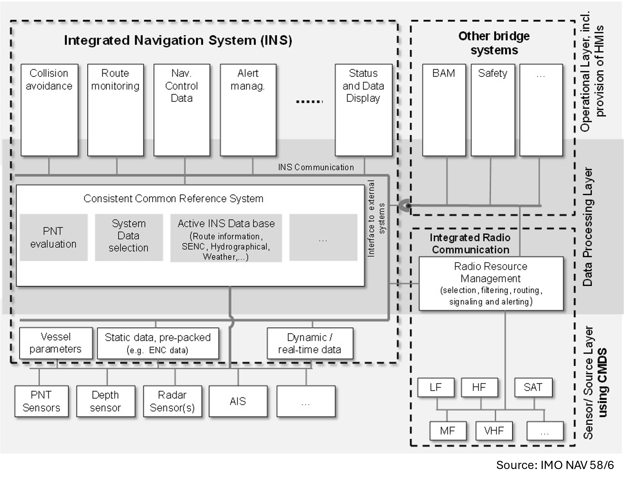
- Generic shipboard navigation system architecture in the context of e-navigation.
The shipborne navigation system architecture structures sensors, data processing, presentation, and communication systems into a modular and coherent system that supports standardisation and enables the development of global interoperability through standardised interfaces. This makes it possible for shore-based authorities to develop digital services with a clear understanding of how information sent from shore will be received, processed, and presented onboard.

Common shore-based system architecture
The Common Shore-based System Architecture (CSSA), developed by IALA, provides a modular, scalable, and standardised shore-based system architecture that improves interoperability, lifecycle management, and cost efficiency, and directly supports the digitalisation in the maritime domain. The guideline G1113 Design and Implementation Principles for Harmonized System Architectures of Shore-based Infrastructure introduces the general principles for the design and implementation of the CSSA, while G1114 Technical Specification for the Common Shore-based System Architecture (CSSA) provides best practices for the use of the architecture.
The CSSA architectural framework is a layered, service-oriented architecture geared towards the data and information flows implied by the overarching e-navigation architecture and is therefore functionally similar to the layered shipboard navigation system architecture. The top-level structure of the CSSA is illustrated in Figure 13, where the arrows indicate data and information flows between its different functional components.
The functional services of CSSA are:
- Data Collection and Data Transfer services: Interface with the waterway, including vessels, AtoNs and the physical environment.
- Value-Added Data Processing services: Pre-process, evaluate and store data. These services form the data and information core of the CSSA.
- The User Interaction Services: Provide HMI to the primary users of the CSSA, namely operators in centres operated by authorities that also operate the shore-based system.
- Gateway service: Allows data to be exchanged with systems of other shore-based stakeholders, as well as with external information, telecommunications, and internet service providers.

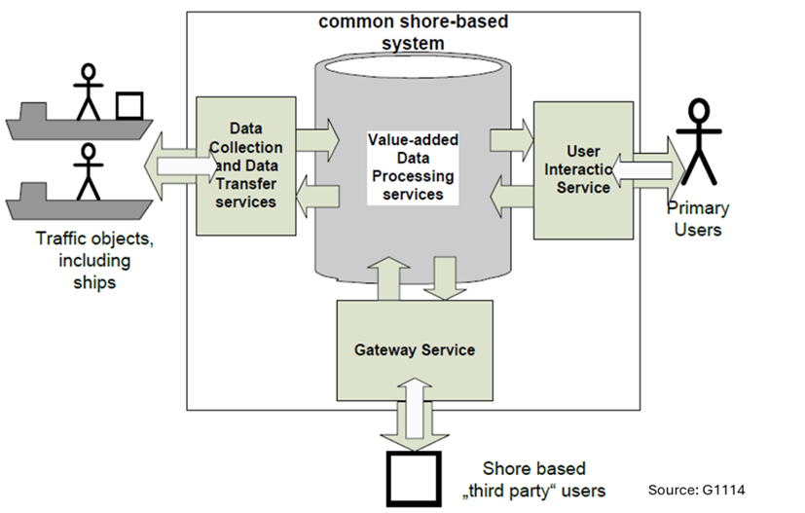
- Structural overview on Common Shore-based System Architecture (CSSA).
CSSA can be used to support the development of new services. It proves a structured path from identifying operational user needs and deriving system requirements to defining technical services and interfaces. It ensures the modularity, interoperability, and scalability of the design.

Maritime system interconnection architecture

When multiple cooperative communication relationships are operating simultaneously, architectures for complex cooperative technical systems are needed to address the associated complexities. The C-ITS System Interconnection Architecture [17] can be adopted for the waterway domain with some amendments; in this context, it may be referred to as the Maritime System Interconnection Architecture (Figure 14).
The Maritime System Interconnection Architecture defines the following communication domains:
- Vessel-to-Vessel communications domain
- On-board communications domain
- Vessel-to-Waterway Infrastructure communications domain
- Wireless-to-Fixed communications domain
- Fixed-to-Fixed communications domain.

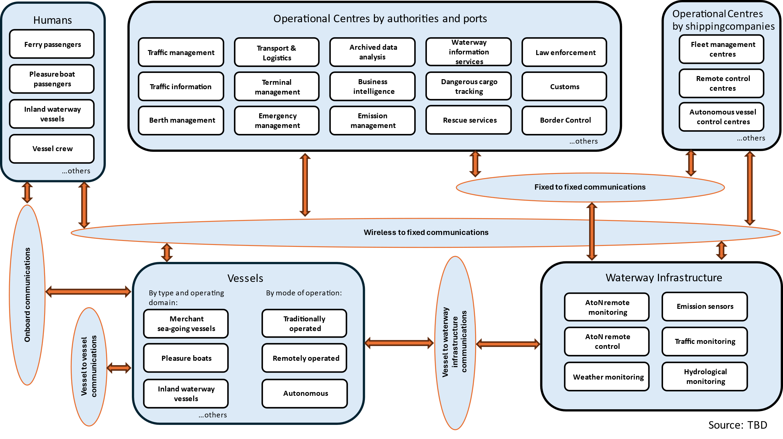
- Maritime System Interconnection Architecture.
Using the interconnection architecture to study operational relationships supported by the communication domains provides a powerful architectural means to identify and justify useful, and potentially even optimal, combinations of communication technologies. It offers the following benefits:
- By assigning each digital communication technology under consideration to one or more communications domains, the versatility of each technology or lack thereof, becomes apparent. This allows the selection of the most versatile communication technologies for deployment in one or potentially several communication domains, provided that all required functionalities can be supported.
- Datalink communications may use one or more functional link paths between the entities they connect and may additionally act as relays. This not only highlights the resulting need for interfacing, specification, and standardisation throughout the functional link paths, but also indicates potential fall-back routes for each datalink communication using alternative functional links and, where applicable, entities acting as relays.
- Once adopted by all relevant stakeholders in the waterway domain, interconnection architecture may serve as a powerful community tool for harmonising the descriptions, definitions, specifications, and standardisation of functional and physical communication links, thereby supporting operational relationships between all involved entities.

Maritime architecture framework

Technology and technical services that employ it are always embedded in socio-technical systems. This creates a requirement for an additional architectural framework that allows the business, operational and technical perspectives of the waterway domain to be brought together within a socio-technical system context, enabling:
- Targeted harmonisation of existing, but potentially conflicting, documents, which have often been developed by different stakeholder domains over extended periods of time and have never previously been brought into contact with each other.
- Targeted development of missing documents to address identified gaps.
In general, the framework architecture provides a means to overcome silos and to identify overlaps or gaps within the socio-technical system under consideration and is therefore required to achieve any level of digitalisation beyond simple digitisation of information.
The Maritime Architecture Framework (MAF) [18] has been developed from the Reference Architecture Model for Industry (RAMI) [19]. It addresses the complexity of the maritime domain by offering a standardized method for analysing, designing, comparing, and discussing maritime system architectures. It enables the consistent consideration of technical, organisational, and conceptual aspects and ensures that new digital solutions are integrated into the existing maritime environment.
MAF integrates a three‑dimensional model, referred to as the cube, that visualises architectural aspects and helps to identify interoperability issues, gaps, and overlaps. The MAF cube represents characteristics of the maritime domain using three dimensions: the hierarchical, topological, and interoperability axes (Figure 15). It is structured into layers that slice the cube into categories along each dimension. Accordingly, the term “axes” is used to denote a dimension, and “layer” refers to surface containing all aspects belonging to a specific category. All aspects within a layer can be further sub-structured according to the categories of the other dimensions.
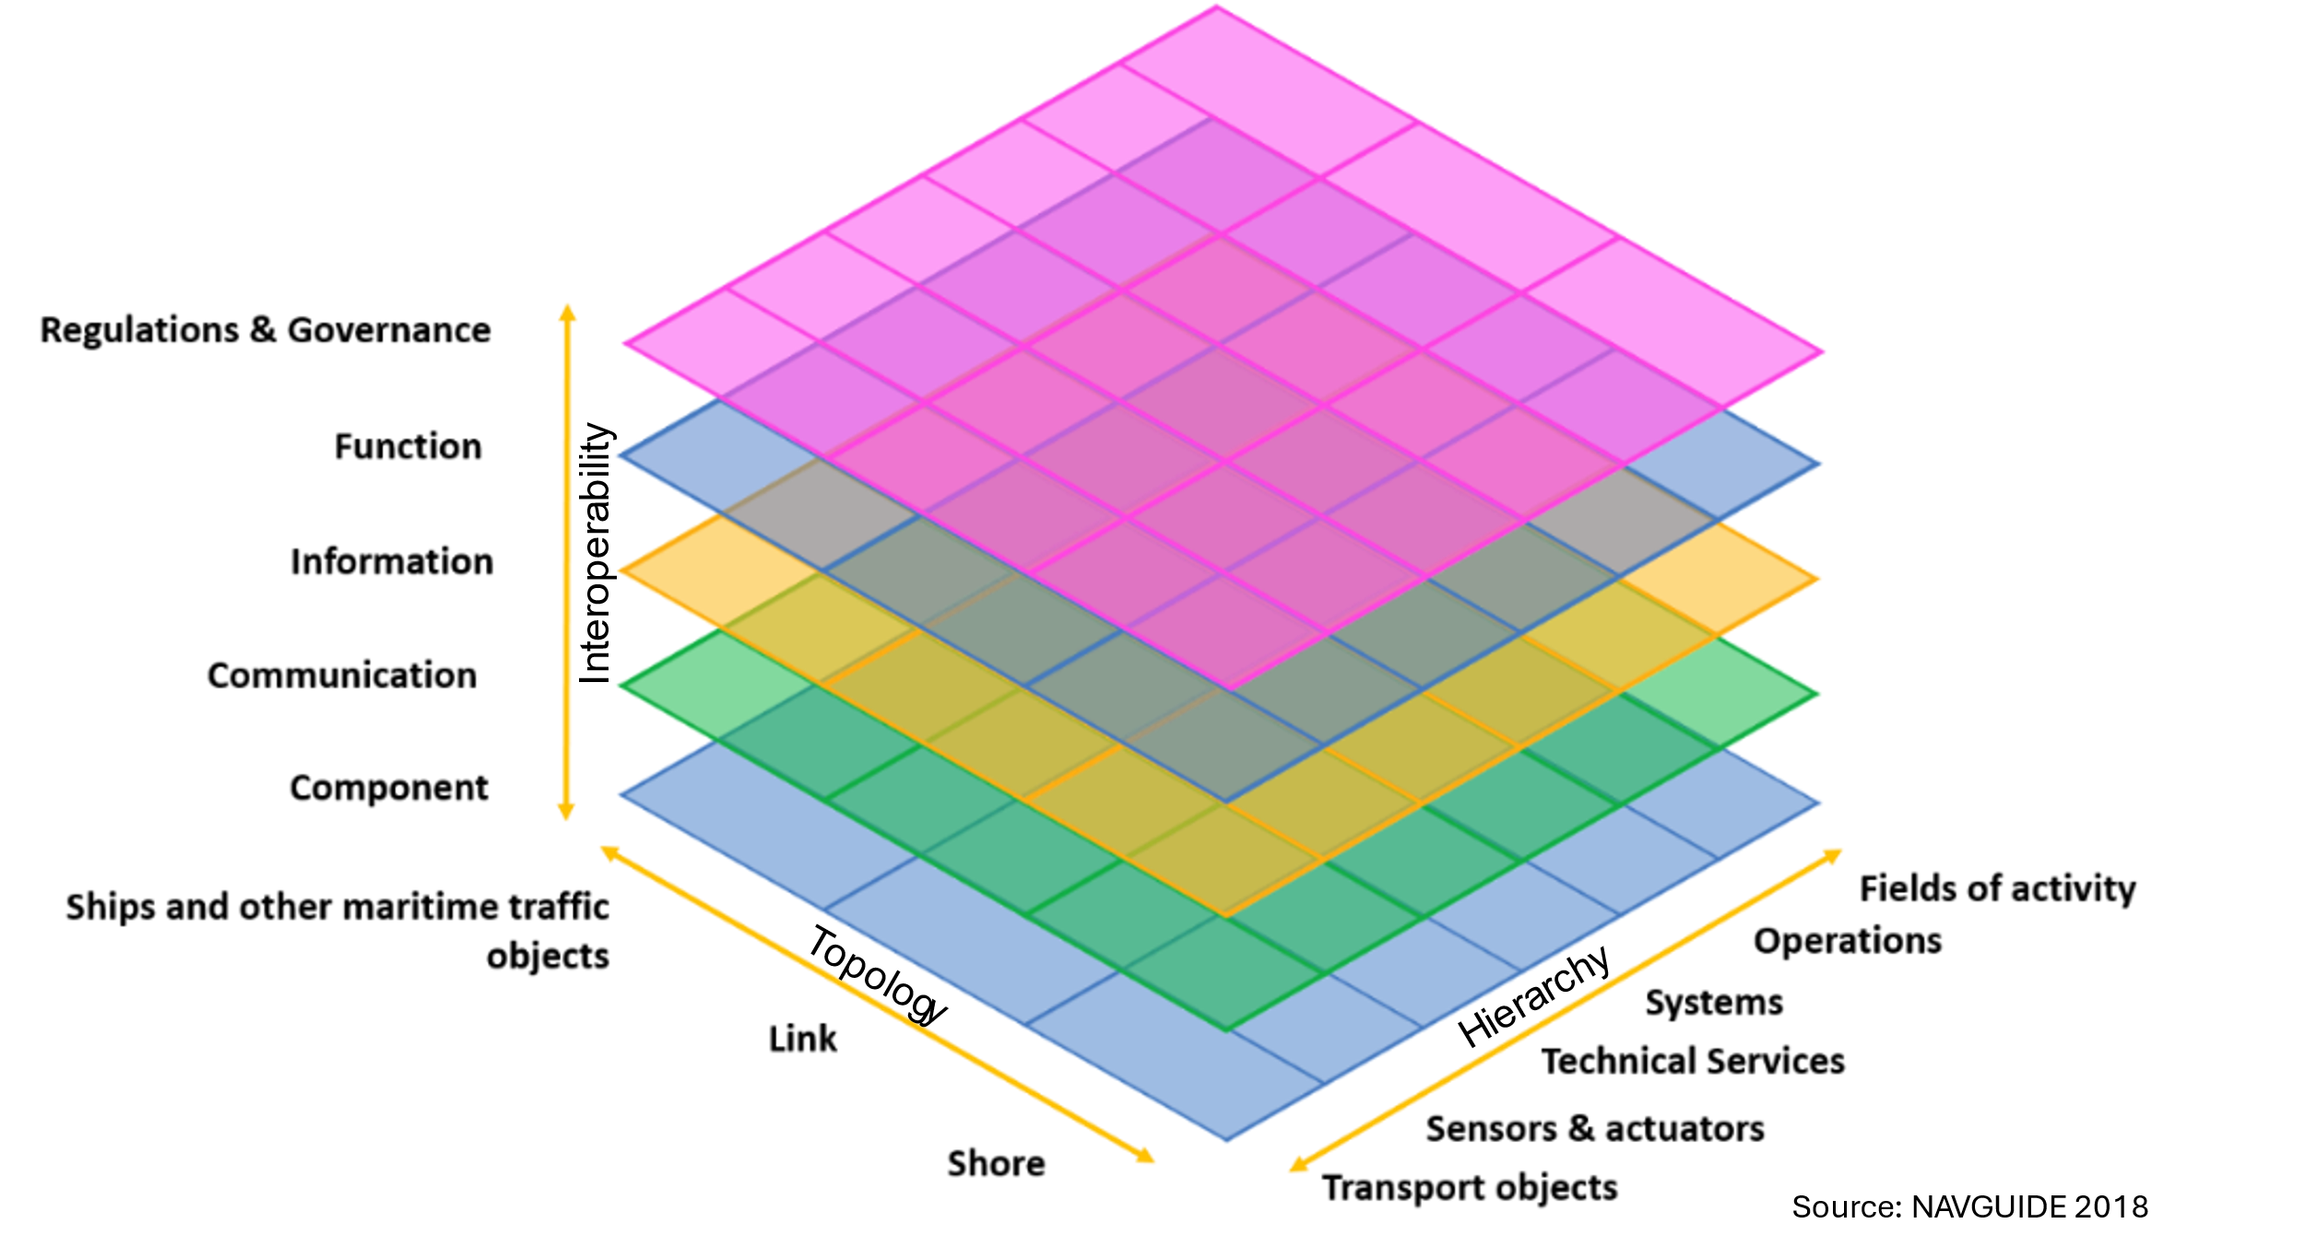
- Maritime Architecture Framework with layers along interoperability axis.
The layers of the hierarchical axis reflect the structure and aggregation of organisational aspects and control systems in the maritime domain. Each layer addresses both technical and human aspects. These layers help to understand the definition and role of operational services, such as those described in the IMO Maritime Services. This includes their provision by technical systems delivering technical services. The layers are:
- Transport objects: Entities involved in maritime transport processes, such as vessels, floating objects, and aircraft operating in the maritime domain.
- Sensors and actuators: Local infrastructure for detecting objects using physical means, and for receiving and processing the results through physical systems and hardware.
- Technical services: Individual technical and logical services.
- Systems: Technical systems that integrate or use technical services to obtain a virtual representation of, and exercise control over, transport processes.
- Operations: Global, regional, national, and local operational perspectives used by companies or authorities (e.g. traffic flow management).
- Fields of activity: Systems that support or manage different markets or ecosystems within the maritime domain.
The layers of the topological axis reflect the structure of the overarching e-navigation architecture. The layers are:
- Ships and other maritime traffic objects: Represent entities in the maritime domain (e.g. vessels). This layer covers the ship-side entities of the e-navigation architecture.
- Link: Represents entities dedicated to physical interaction between maritime traffic objects and shore, such as telecommunication methods and protocols. It represents the three levels of operational, functional, and physical links between the ship-side and shore-side environments.
- Shore: Represents entities of the shore-side infrastructure, activities, and systems on shore, including interfaces to logistical movements into and out of the maritime domain.
The layers of the interoperability axis cover organisational, informational and technical aspects and include different levels of interaction (operational, functional, technical and physical). The layers are:
- Component: Required components in engineering terms, including, amongst others, systems, actors, applications, services, and network infrastructure.
- Communication: Protocols and mechanisms for the interoperable exchange of data between components.
- Information: Data and information used and exchanged between functions, services, and components. This layer describes data and information objects, including its semantic and data models.
- Function: Functions and (elementary) services, including their relationships.
- Regulations and governance: The roles and legal bases of international, regional, and national (shipping) authorities.

DEFINITIONS

The definitions of terms used in this Guideline can be found in the International Dictionary of Marine Aids to Navigation (IALA dictionary) at http://www.iala-aism.org/wiki/dictionary and were checked as correct at the time of going to print. Where conflict arises, the IALA Dictionary should be considered as the authoritative source of definitions used in IALA documents.
Preliminary tentative list of terms used in the guideline:
- Autonomous vessel
A vessel, which decision-making and execution of navigation (‘sailing’) are performed autonomously in the strict sense of the word and as the regular case by an appropriate machinery of the vessel itself without on-board or remote human interaction. Whether the autonomous vessel actually is crewed or uncrewed is irrelevant in regards to its navigating functions as long as the shipboard machinery performs them as the intended regular case.
- Autonomous Vessel Control Centre
A shore-based centre that monitors and controls autonomous vessels and is operated by or on behalf of the shipping company that also operates the autonomous vessels. Since an autonomous vessel, by its very definition, does not need a operation by crew or human remote control in regular cases, there will likely be a requirement that it is constantly monitored and contingency response is active in non-regular modes of operation or even malfunction. Hence, Autonomous Vessel Monitoring & Contingency Response is the main functionality to be performed by the autonomous vessel control centre. Since autonomous vessels may fall back to remote operated vessels as part of the contingency response, the autonomous vessel control centre may also fall back to a remote-control centre.
- Common Shore-based System Architecture
The CSSA is defined as a standardized framework to harmonize shore-based marine aids to navigation (AtoN) systems. The CSSA provides a modular, interoperable, and flexible architecture for managing and controlling marine AtoNs such as lighthouses, buoys, beacons, and other navigation aids, especially when these devices are remotely monitored or controlled.
- [Digitalized waterway]
Comprehensively utilizing surveying and mapping remote sensing, geographic information system, computer, Internet of Things, cloud computing and other technologies to digitalize and network waterway jurisdiction areas, service objects and management activities, and establish waterway information infrastructure and platform systems with network-oriented data as the core. It has the functions of dynamic monitoring of waterway changes, waterway maintenance, network management, waterway data
- Match principle
In digitalization, the match principle generally refers to aligning digital solutions or technologies closely with the specific needs, processes, and goals of a business or system. It means ensuring that the digital tools “match” the actual requirements rather than just adopting technology for technology’s sake.
- Remote Control Centre
A shore-based centre that performs the remote operation of remotely operated vessels and is operated by or on behalf of the shipping company that also operates the remotely operated vessels.
- Remotely operated vessel
A vessel, which navigating functions are performed remotely as the regular case from a remote-control centre by a human at that centre. Whether a remotely operated vessel is actually crewed or uncrewed is irrelevant in regards to its navigating functions as long as they are performed remotely as the intended regular case.
- [Smart/digital AtoN]
A smart AtoN is an advanced navigational aid equipped with sensors and communication technology that enables it to monitor, collect, and transmit real-time data about its status and the surrounding marine environment. Unlike traditional AtoNs, which rely solely on fixed signals (lights, shapes, sounds), smart AtoNs provide dynamic information that can be accessed remotely by Vessel Traffic Services (VTS) and mariners to enhance situational awareness, safety, and efficiency of navigation.
- Traditionally operated vessel
A vessel, which navigating functions are performed by a crewmember on-board by using appropriate Human-Machine-Interfaces (HMI) designed for that task. The degree of automation supportive of that task is encapsulated within the traditional operation and is therefore irrelevant here as long as the on-board human master is in charge of the vessel’s navigation.
- Vessel
Ship or large boat (Cambridge dictionary) with purpose of carrying cargo and/or persons.
- Waterway
A waterway is a navigable route through a body of water marked and maintained with marine AtoNs to ensure safe passage for vessels.

abbreviations

2D Two Dimensional
3D Three Dimensional
4G Fourth Generation
5G Fifth Generation
AI Artificial Intelligence
AIS Automatic Identification System
AML Additional Military Layers
ASF Additional Secondary Factors
ASM Application Specific Messages
ATON Aids to Navigation
BAM Bridge Alert Management
CAS Information to support Calamity Abatement (CAS)
CAT Category of ILS Approach
CCTV Closed-Circuit Television
CHD Information for Waterway Charges and Harbour Dues
C-ITS Cooperative Intelligent Transport Systems
CMDS Common Maritime Data Structure
CMM Capability Maturity Model
CSSA Common Shore-based System Architecture
DGNSS Differential GNSS
DIWA Masterplan Digitalisation of Inland Waterways
ECDIS Electronic Chart Display and Information System
ENC Electronic Navigational Chart
FIS Fairway information Services
GIS Geographic Information System
GMDSS Global Maritime Distress and Safety System
GMWG Geospatial Maritime Working Group
GNSS Global Navigation Satellite System
HF High Frequency
HMI Human-Machine Interface
IALA International Organization for Marine Aids to Navigation
IEC International Electrotechnical Commission
IEHG Inland ENC Harmonization Group
IHO International Hydrographical Organization
ILC Information to support Law Compliance
ILS Instrument Landing Systems
IMO International Maritime Organization
IMT International Mobile Telecommunications
INS Integrated Navigation System
IOC Intergovernmental Oceanographic Commission
IoT Internet of Things
IP Internet Protocol
ITL Information to support Transport Logistics
LF Low Frequency Information to support Transport Logistics
LoRaWAN Long Range Wide Area Network
MF Medium Frequency
MAF Maritime Architecture Framework
MASS Maritime Autonomous Surface Ship
MCP Maritime Connectivity Platform
MIT Massachusetts Institute of Technology
MS Maritime Service
MSC Maritime Safety Committee
MSI Maritime Safety Information
NATO North Atlantic Treaty Organization
NAVTEX Navigational Telex
PIANC World Association of Waterborne Transport Infrastructure
RAMI Reference Architecture Model for Industry
RENC Regional ENC Coordinating Centres
RIS River Information Service
PNT Position, Navigation and Timing
SAT Satellite Communications
SECOM Secure Communication between Ship and Shore
SERCOM WMO Service Commission
SOLAS International Convention for the Safety of Life at Sea
ST Information to support Statistics
TIS Traffic information Services
TM Information to support Traffic Management
TRL Technology Readiness Level
UKCM Under Keel Clearance Management
UNECE United Nations Economic Commission for Europe
VDE VHF Data Exchange
VDES VHF Data Exchange System
VHF Very High Frequency
VTS Vessel Traffic Service
WMO World Meteorological Organization

references

- TM Forum White Paper. Digital Maturity Model (DMM): A blueprint for digital transformation. 2017.
- Lind, Mikael & Haraldson, Sandra & Lind, Kenneth & Lehmacher, Wolfgang & Svan, M & Renz, Mikael & Gardeitchik, J & Singh, Sukhjit & Zuesongdham, Phanthian. (2021). Ports of tomorrow: measuring digital maturity to empower sustainable port operations and business ecosystems. 82.
- Wouter Buck (Product Lead, Digital Business Solutions), Jan Gardeitchik (Senior Lead Digitisation, Digital Business Solutions), Arny van der Deijl (Tech Lead, Digital Business Solutions). Port of Rotterdam: Move Forward: Step by Step towards a Digital Port.
- ISO/IEC. (2025) ISO/IEC 30186 ED1 Digital twin – Maturity model and guidance for a maturity assessment. ISBN 9782832705643.
- Oltmann, J.-H. (2023) Technology in other modes of transport. DIWA Sub-Activity 3.5 Report.
- English Wikipedia. (2025) Capability Maturity Model. Accessed 29 January 2026.
- IALA. IALA Workshop on Marine AtoN in the Autonomous World. Workshop Report.
- International Organization for Standardization. (2022) ISO/TS 23860:2022. Ships and marine technology – Vocabulary related to autonomous ship.
- Tchana de Tchana, Yvan & Ducellier, Guillaume & Sébastien, Remy. (2019). “Designing a unique Digital Twin for linear infrastructures lifecycle management.” Procedia CIRP. 84. 545-549. 10.1016/j.procir.2019.04.176.
- IALA e-Bulletin, March 29, 2023. Finland – remote controlling AtoN lights. Available online: https://www.iala-aism.org/e-bulletin/e-bulletin-march-2022/finish-transport-infrastructure-agency/
- IMO. Strategy for the development and implementation of e-navigation (MSC 85/26/Add.1, annex 20)
- IMO. Descriptions of Maritime Services in the Context of e-Navigation (MSC.1/Circ.1610/Rev.1).
- PIANC. Inland Navigation Commission Report No 125/I Guidelines and Recommendations for River Information Services. 2019. ISBN 978-2-87223-265-9.
- IMO MSC.1/Circ.1595, e-Navigation Strategy Implementation Plan – update 1, 25 May 2018
- IMO SN.1/Circ.289, Guidance on the Use of AIS Application-Specific Messages
- COMMISSION REGULATION (EU) No 139/2014 of 12 February 2014 laying down requirements and administrative procedures related to aerodromes pursuant to Regulation (EC) No 216/2008 of the European Parliament and of the Council.
- ITU. 2021. Intelligent transport systems. Handbook on Land Mobile (including Wireless Access). Volume 4. 2021 edition. Geneva: ITU. 2021.
- NAVGUIDE 2018.
- German Federal Ministry for Economic Affairs and Energy. Website: Platform Industrie 4.0. https://www.plattform-i40.de/IP/Navigation/EN/Home/home.html. Accessed 29 January 2026.

Further reading

- [TBD]

